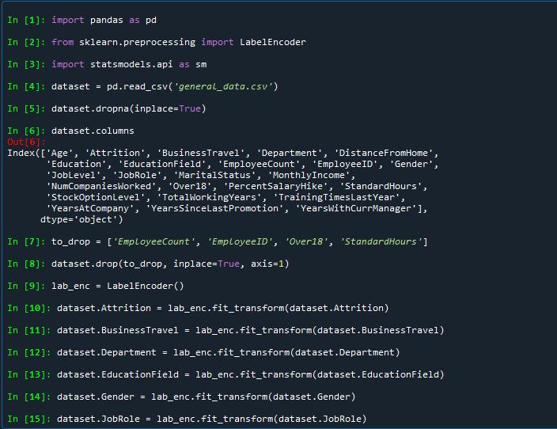

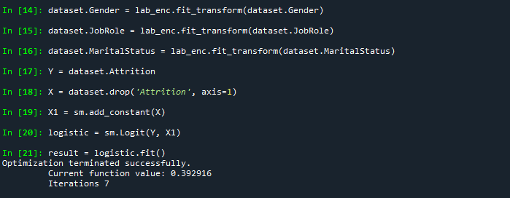

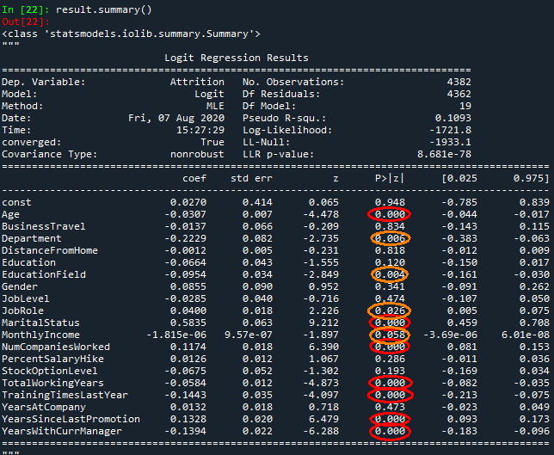

Age, MaritalStatus, NumCompaniesWorked, TotalWorkingYears, TrainingTimesLastYear, YearsSinceLastPromotion and YearsWithCurrManager (In Red) have a p-value of 0, indicating a very close relation with Attrition

Department, EducationField, Job Role and Monthly Income (In orange) also have a p-value of very close to 0, and hence show high relation with Attrition